IN THE 51ST JUDICIAL DISTRICT COURT
IN THE 119TH JUDICIAL DISTRICT COURT
IN THE 340TH JUDICIAL DISTRICT COURT IN THE 391 ^{ST} JUDICIAL DISTRICT COURT
SCHEDULE OF FEES FOR APPOINTED ATTORNEYS
The following guidelines and rules have been approved by the above Courts regarding payment of fees and expenses of attorneys who are appointed under Texas Code of Criminal Procedure §26.05.
I. Fixed Fees.
The following fixed fees are approved for all time spent in court on behalf of the defendant, all reasonable and necessary time spent out of court in the case, and all expenses incurred by the attorney in the case, except for such expenses approved by the Court in a prior Order.
a. | Guilty pleas or plea of no contest before the court | $750.00
b. | True plea to a Motion to Revoke | $750.00
c. | Motion to Revoke resolved by Amended Conditions of Probation | $250.00
d. | In a second case involving the same Defendant that is disposed of as part of the Plea in another case | $750.00
e. | In third and subsequent cases involving the same defendant that are disposed of as a result of a plea in another case | $250 to $400 per case as determined by the court.
Il. Hourly Fees, Trial of Non-capital Cases.
The Court will determine the appropriate hourly rate based upon the complexity of the case and the experience and ability of the appointed attorney. Except in Capital cases, for services as a trial attorney, the following are the minimum and maximum hourly rates:
Maximum hourly rate, SJF and 3rd Degree | $90.00
Maximum hourly rate, 1st and 2nd degree | $125.00
Hourly rate for travel time | $30.00
Hourly Rate, MTR | $75.00

The fee is for services rendered until charges are dismissed, the defendant is acquitted, completion of trial and any post-trial proceedings in the trial court (including filing and presenting a Motion for New Trial), or the attorney is relieved of duties by the court or replaced by other counsel.
If an attorney is appointed to represent a Defendant in multiple cases and the attorney requests a fee based on an hourly rate, the attorney shall submit one request for attorney fees that is for all time spent on all of the cases. Unless requested by the court, it is not necessary for the attorney to divide the time among the several cases.
Ill. Capital Cases.
The Court may deviate from this schedule if necessary to appoint qualified counsel. Subject to the availability of qualified attorneys, the following are the hourly rates in Capital cases:
Hourly rate for lead counsel | $125.00
Hourly rate for second chair | $80.00
Hourly rate for travel time | $40.00
- Appeals.
The Court will determine the appropriate hourly rate based upon the complexity of the case and the experience and ability of the appointed attorney. Generally, the following are the minimum and maximum hourly rates:
Minimum hourly rate | $75.00
Maximum hourly rate | $75.00
Hourly rate for travel time | $30.00
This fee is for services rendered for all appellate services.
- Expenses and Non Standard Fees.
Except as provided below, attorneys should request approval from the Court for expenses before incurring the following: travel, investigation, expert witness fees and other expenses. Following are the guidelines for expenses:
- Travel: Travel by private automobile is reimbursed at the state employee mileage rate, , plus parking fees. Attorneys do not need pre-approval for travel within the counties that comprise the 51 ^{st}, 1 1 9th, 340th and 391 ^{st} Judicial Districts. Other means of travel will be reimbursed for the actual costs of regular fares. Expenses for meals and lodging •are reimbursed at the state employee rates. Despite the above schedule, all out-of-state travel and travel by commercial transportation must be pre-approved by the court.
- Investigation and Expert Witnesses: Investigation expenses and expert expenses are governed by the Code of Criminal Procedure Articles 26.05(d) and 26.0520, (g) and (h). See also the "Second Supplement to Tom Green County Indigent Defense Policy" dated June 24, 2003. Ordinarily, investigation by private investigators shall be at a rate not to exceed $35.00 per hour for investigation and $25.00 per hour for travel.
- Request for Attorney Fees.
"No payment shall be made under this section until the form for reporting the services performed is submitted and approved by the court and is in accordance with the fee schedule for that county." Texas Code of Criminal Procedure Art. 26.05.
The Courts have approved a form "Request for Attorney Fees", a copy of which is attached. If an attorney is requesting a fixed fee, the attorney must complete Section I of the Request. If the attorney is requesting a fee based on an hourly rate, the attorney must complete Section Il of the Request, including attaching a time sheet that describes the date services were performed, a brief description of those services, the time spent (which must be in increments of 1/10th of an hour), and the hourly rate requested. Claims for either services, expenses or both will be considered only if properly documented.
- Non Standard Fees and Miscellaneous Provisions.
In the interest ofjustice, forjust cause, or in exceptional cases, the Court in its discretion may approvefees that differ from this schedule.
These rules and guidelines are adopted in compliance with the Texas Code of Criminal Procedure and may be amended at the discretion of the Courts.
The District Judges adopted the hourly rates set forth above, and Ordered that the fee schedule be amended accordingly, at a meeting of Judges Barbara Walther, Ben Woodward, Jay Weatherby, and Tom Gossett on June 15, 2016. That Order was reduced to writing on June 17, 2016, a copy of which is attached.
The District Judges adopted the increased Fixed Fees as set forth above, and Ordered that the fee schedule be amended accordingly, at a meeting of Judges Barbara Walther, Ben Woodward, Jay Weatherby, and Tom Gossett on August 10, 2016. This Schedule reduces to writing the Order rendered by the Courts on August 10, 2016.
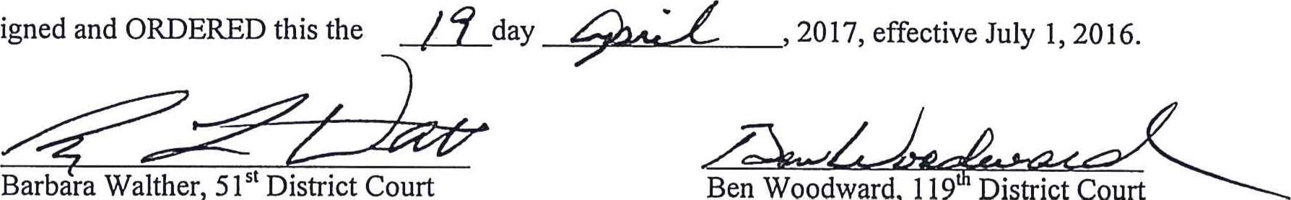
Signed
Ben
Woodward,
119
District
Court
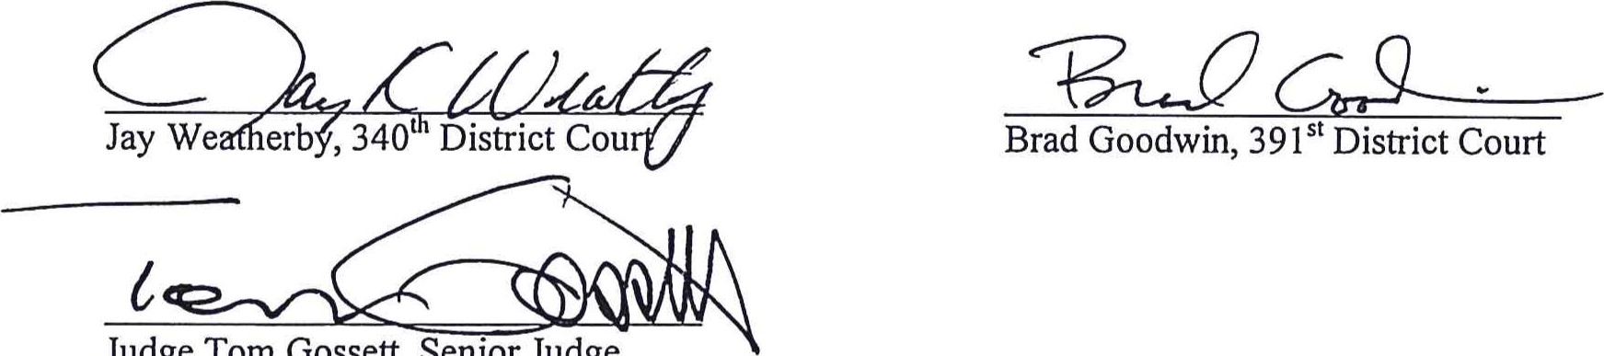
Judge
Tom
Gossett,
Senior
Judge

